Time for a change?
Books to Reinvent Yourself

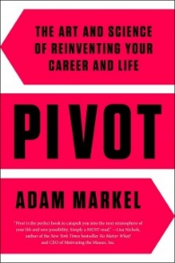
Pivot: the art and science of reinventing your life
by Adam Markel
The CEO of Peak Potentials describes how anyone can tap their true potential. Learn to squash damaging beliefs, build a support network, and establish habits to win at work and in life.

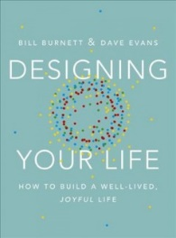
Designing your life: how to build a well-lived, joyful life
by William Burnett
Use tested design principles to re-frame, act, and collaborate to design your best-fit life. Written by the executive director of the Design Program at Stanford.

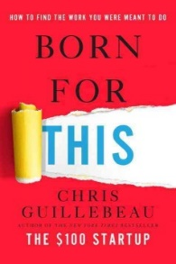
Born for this: how to find the work you were meant to do
by Chris Guillebeau
Build a career or a side-gig that melds your passions and skills, and meets your financial needs. Written by the author of $100 Startup and The Happiness of Pursuit.

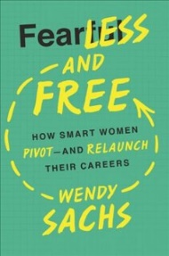
Fearless and free: how smart women pivot and relaunch their careers
by Wendy Sachs
Find the motivation to take risks, pivot and try something new. Offers guidance for women looking to succeed in the rapidly changing job market.

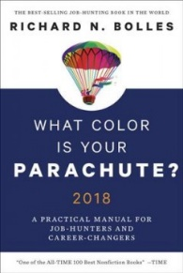
What color is your parachute?: a practical manual for job-hunters and career-changers
by Richard Nelson Bolles
Updated for 2018, this is the world’s most popular job-search book. Learn what works and what doesn't when looking for your dream job.

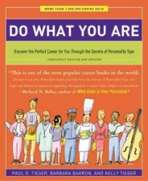
Do what you are: discover the perfect career for you through the secrets of personality type
by Paul D. Tieger
Delve into your personality type to find your best-fit careers. Filled with worksheets and helpful job seeking tips that fit your unique personality.

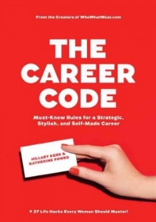
The career code: must-know rules for a strategic, stylish, and self-made career
by Hillary Kerr
The co-founders of the hugely successful Who What Wear empire share helpful tips for working women, including resume writing, salary negotiation and workplace etiquette.


Strategize to win: the new way to start out, step up, or start over in your career
by Carla A. Harris
Set goals and improve your performance to achieve more at work and move up the corporate ladder.


Pivot: the only move that matters is your next one
by Jenny Blake
Discover the keys to both small and large changes in your career and personal life.The best-selling author of Life After College shares strategies for meeting the demands of today's increasingly dynamic, high-turnover economy.

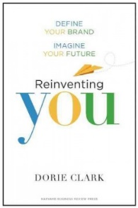
Reinventing you: define your brand, imagine your future
by Dorie Clark
Use the proven techniques of branding to tell your story and land your dream job. Clark offers success stories to back up her suggestions for formulating and launching your personal brand.

The Success Principles by Jack Canfield (for both client and self)

Cultural Intelligence by David Livermore

Generations at Work by Ron Zemke

Social Networking for Career Success by Miriam Salpeter

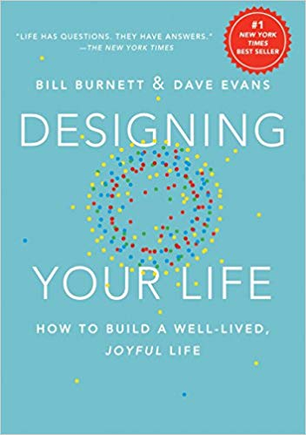 Designing Your Life: How to Build a Well-Lived, Joyful Life

