National Career Development Association
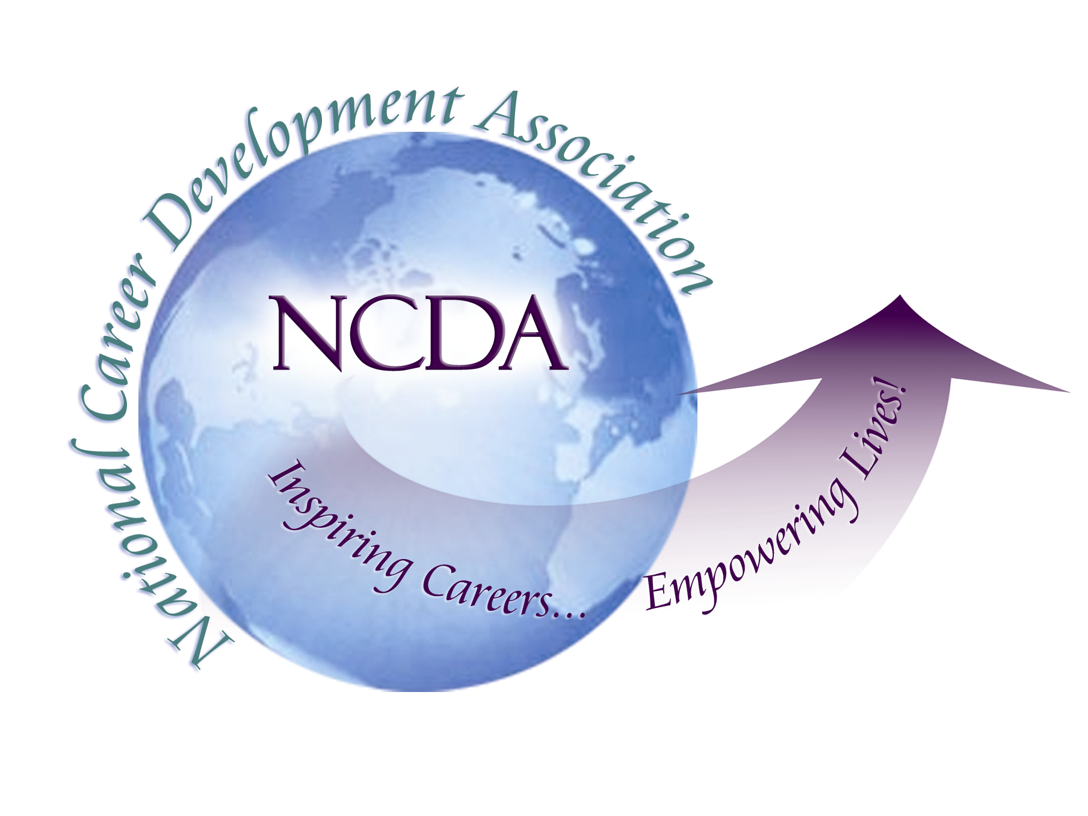
305 N. Beech Circle
Broken Arrow, OK 74012
918/663-7060
Fax: 918/663-7058
www.ncda.org

Career Practitioners are Vital in
Developing the US Workforce

Contact: Deneen Pennington, Executive Director
866-367-6232 or dpenn@ncda.org
Date September 1, 2011
Subject NCDA’s National Survey on Working America

Broken Arrow, OK – As the US job market continues to diminish, it is increasingly important for job-seekers to look to career practitioners to develop the career-planning competencies needed to find a job that matches their preferences and skill-set.

The National Career Development Association (NCDA) commissioned Harris Interactive to conduct a National Survey of Working America. The poll assessed the perceptions of today’s workforce on the effectiveness of career counselors, the need for expanded workforce training opportunities and the hardships implicit in selecting, changing or getting a job in the current economic climate. The feedback is very clear: career practitioners are a vital resource for the livelihood of our nation’s workforce and are underutilized relative to their potential need and value.

In the 2011 Poll, only one quarter (24%) of adults report that they have already visited a career practitioner and 86% of those found them to be helpful. Only 37% of respondents reported making a conscious choice when choosing a career while over half (56%) took the only job available, looked interesting at the time, or chose based on the influence of parents/relatives or friends. Nearly four in ten adults in the labor force who say the globalization of the American economy has impacted them believe globalization has changed their job significantly (36%), requiring them to learn new skills (36%) and impacting their job/career prospects (35%). This is significantly higher than what was reported in 1999, when one in five (18%) employed adults believed it would change the way they do their job.

This survey was conducted by phone among 1,000 adults, 18 years of age or older. The sample represents a total population of 185.2 million adults, based on the U.S. Census current population reports, and was comprised of 49% males and 51% females. The study examined adults’ attitudes and experience related to work and the selection of a career or job. Interviews were conducted from April 18 – May 2, 2011. Complete National Survey Data and video clips are available at www.ncda.org.

The National Career Development Association is an association of 5000 career development professionals who work in education, business and industry, community and government agencies, and private practice. NCDA inspires and empowers the achievement of career and life goals by providing professional development, resources, standards, scientific research, and advocacy.

