NCDA ANNUAL REPORT
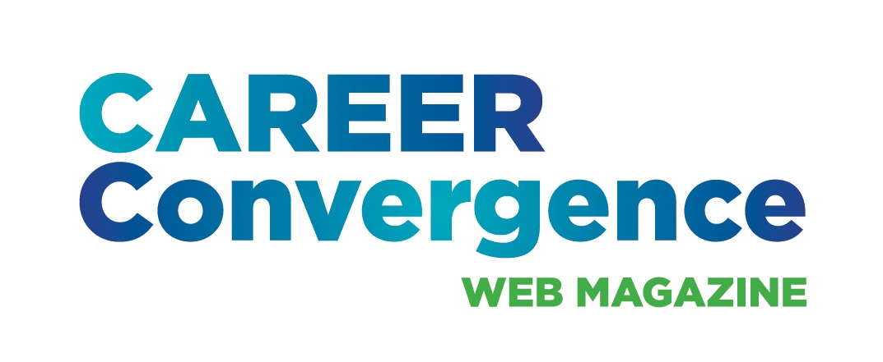

CAREER CONVERGENCE WEB MAGAZINE
September 1, 2024

Editor: Melanie Reinersman, webeditor@ncda.org

Associate Editors: Natasha Barnes, Brittany Collins, David Dietrich, Jane Frisch, Candina Janicki, Vonya Hodrick, Meredith Montgomery, Elyse Pipitone, Billie Streufert
Field Editors: Mason Murphy, Willa Smith, Regina Gavin Williams

Activities to Date

- Published new issues on the first of each month (except Jan 1 and July 1), bringing the total issues up to 222, since 2003 (Strategic Goal #2- Career Empowerment: Publications)
- Published 7 new articles, plus one Tech Tip, each month. Electronic distribution to over 30,000 emails on the first of the month and over 1650 articles archived
- Achieved record-high hit rates for articles on artificial intelligence (AI), ikigai, and values, as well as on the series on teaching theory, from the Counselor Ed Academy participants (Strategic Goal #2- Career Empowerment: Publications)
- Held a conference call on Dec 6, 2023 and met at the 2024 NCDA conference
- Monitored comments posted on articles
- Social media each month handled by NCDA Social Media coordinator, with links to the issue and each article (Strategic Goal #1- Community: Recruitment)
- Selected (by editors’ votes) the annual “Career Convergence Recognition Award” winner (Strategic Goal #1- Community: Engagement)
- Published articles in cooperation with NCDA committees, e.g., a series from the Global Career Connections Committee (Strategic Goal #1- Community: Engagement); and articles from DICI and Gov’t Relations (Strategic Goal #3- Advocacy)
- Implemented a new AI policy regarding submissions
- Fulfilled 5 requests for CEs (Strategic Goal #2- Career Empowerment: Professional Development)
- Completed the 20th anniversary celebration of the web magazine, including a podcast on using Career Convergence (Strategic Goal #1- Community: Engagement)
- Selected 2 new co-associate editors (Jane Frisch and Brittany Collins) and 1 new field editor (Regina Williams); (Strategic Goal #2- Career Empowerment: Professional Development)

Projected Plan/Work Completed through September 30.

- Continue to publish monthly web magazine
- On-board 1 new co-associate editor (for the Independent Practice dept)

