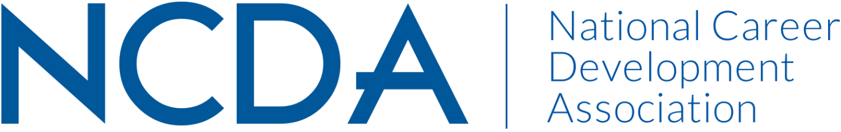

***Annual Report 2023-2024***

**INTERNATIONAL STUDENT SERVICES COMMITTEE**

**September 1, 2024**

**Committee Members & Leadership**

* *2023/2024 Co-chairs:* Ellen Goldman, [e.goldman@northeastern.edu](mailto:e.goldman@northeastern.edu)) & Kelly Woods, [krwoods@mtholyoke.edu](mailto:krwoods@mtholyoke.edu)
* *2024/2025 Co-chairs:* Ellen Goldman, [e.goldman@northeastern.edu](mailto:e.goldman@northeastern.edu)) & Leigh Oliveras, [leigh.oliveras@sv.cmu.edu](mailto:leigh.oliveras@sv.cmu.edu)
* *2023/2024 Active Members:* Abby Senuty, Alexus Garrett, Ann-Marie Williams, Breanna Gallagher, Corissa Wandmacher, Daniel Pack, Dr. Pankaj Desai, Dr. Anupama Malik, Elif Balin, Ellen Zold Goldman, Erica Ford, Hongshan Shao, Ivette Mekdessi, Jane Sitter, Jessica Schueller, June Hyun, Kelly Woods, Leigh Oliveras, Lena Jackson, Logann Todd, Lynette Hepburn-Richardson, Maggie Luo, Mitali, Mrudula Josyula, Nina Roa, Ozzy Girit Heck, Rosie Shen, Sanaz Nabati, Yangyang Liu, Yuleinys Castillo, Zhiqi Liu, Paula lazarim, Audra Boni, Nicole Anderson, Delyash Tsartsaeva

**Committee Activities to Date**

* Six general meetings and more than 40 sub-team meetings were held. The sub-teams include the Social Media Team, the Research Team, the Resources Team and the Mini-Conference Team.
* The Co-Chairs of the committee (Kelly Woods and Ellen Goldman) presented at the 2024 NCDA conference about our conference committee.
* Several members of the Committee presented at the 2024 NCDA conference regarding career development, wellness, and International Students.
* The **Mini-Conference Team** hosted the fourth annual ISSC Mini-Conference on August 9, 2024 with the aim to serve as a beacon for those dedicated to supporting the career aspirations of international students. 172 members registered to attend this conference with 5 presentations and a membership chat. As of 8/28/24 46 attendees were granted continuing education hours. The theme of the conference was “Charting Your Course: Career Navigation for International Students in a Changing Landscape”. The mini-conference team met seven times to plan the event.
* The **Social Media Team** focused on serving career development professionals with avenues to exchange ideas, resources, best practices, programs, recommendations, and innovations for working with international students and employers. The team has grown the [YouTube channel](https://www.youtube.com/channel/UCasVvaXTapAh9qXIvMYf2Mg) to now have 82 subscribers and 13 videos. The [ISSC LinkedIn Group](https://www.linkedin.com/groups/4509171/)’s strategic engagement enabled the group’s growth to 1184 members. The Social Media Team chairs collaborated to host a webinar on May 7, 2024 about *Practitioner experiences using AI Tools in International Student Career Development attended by 43 people* and shared AI resource documents to all attendees.
* The **Research and Writing Team’s contributions in 2023-2024 included:**
  + **Ongoing Project - Career Adaptability of International Students Research:** We are in the data collection phase. [Link to the research project](https://bit.ly/48hvGXL). We are still in need of more participants and working on this.
  + **Budget for Gift Cards:** NCDA budget people worked with us and they purchased and delivered 25 gift cards of $20 totaling $500. The cards will be distributed as soon as we finish the data collection process. Our study IRB approval include 30 cards of $20 so we are still in need of 5 more cards at $20 each totaling $100 that will be possible included in a new budget requirement.
  + **NCDA Conference 2024:** Our research project was accepted, and Paula presented it ("Critical Consciousness and Adaptability in International Students' Career Development") at the Virtual NCDA Conference on July 22, 2024.
* The **Resources Team** clarified when and how to refer to the career guide when members cite resources from the guide; developed new strategies and timeline for the upcoming 2023-2024 resource guide update in order to make more effective and efficient without using too much burdens on team leads and members; and compiled relevant career articles and resources that can be added to the 2023-2024 resource guide. The team reviewed content and identified an interest in both further developing the global search related content as well as developing content related to AI.