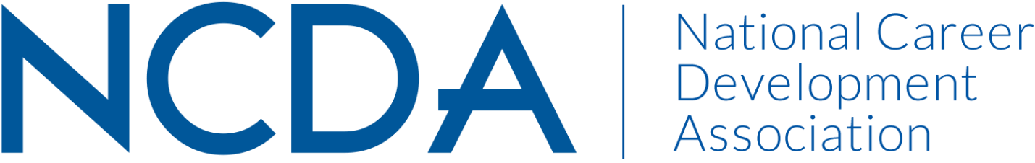

***Annual Report***

**RESEARCH COMMITTEE**

**9/9/2024**

**Chair:**

Deb Osborn

1114 W. Call Street  
The Florida State University  
Tallahassee, FL 32306-4053  
[dosborn@fsu.edu](mailto:dosborn@fsu.edu)

**Co-Chair:**

Jon Borland

East Tennessee State University

PO Box 70701

Johnson City, TN 37614-1710

[borland@etsu.edu](mailto:borland@etsu.edu)

**Co-Chair:**

Brian Calhoun

Associate Professor of the Practice, Department of Education

Tribble Hall - Room A308B

Wake Forest University

P.O. Box 7406  
Winston-Salem, NC 27109

[calhoubm@wfu.edu](mailto:calhoubm@wfu.edu)

**Activities to Date**

* Goal 1: Cultivating community
  + We had several smaller group meetings focused on areas of interest with respect to the research committee to help identify research-related priorities for NCDA and for our group.
  + We generated several possible ideas on how we might increase engagement and collaboration inside of NCDA, as well as how to contribute to the attractiveness of NCDA for potential members through an increased spotlight on scholarship/research as guiding career practice.
  + We have begun collaborating with other groups who have shared interests with respect to research, beginning with CDQ, to examine what can feasibly be done as well as what could be done with additional support. We need to continue with other committees such as the assessment/evaluation/outcomes committee, PDC, and ethics.
* Goal 2: Career Empowerment
  + Our subgroup meetings focused specifically on professional development ideas as well as ideas for promoting our work and the work of our members. As such, we have identified the following top priorities that should be funded by NCDA (budget request included):
    1. Development of briefs (max 5 pages) on evidence-based practices for varied topics (career indecision, career transitions, etc.).
    2. Development of guidelines for practitioner-conducted research.
    3. Update the 2013 state of career interventions white paper.
    4. Development of guidelines for evaluating interventions.

In addition, we would ask NCDA to prioritize the following with respect to research:

1. Create a more visible place on the NCDA website for research.
2. Create opportunities for making connections between experienced/new researchers, students/faculty, researchers/practitioners.
3. Develop an "Evidence-based intervention spotlight" for Career Convergence
4. Consider creating a "research track" throughout the conference schedule

* Goal 3: Advocacy
  + We discussed the importance of funding/highlighting research that is responsive to current national and international needs.
* Other activities:
  + We updated the requirements and rubric and for graduate student research grant submissions.
  + We now have 2 co-chairs.

**Projected Plan through fiscal year end (September 30th)**

* We have accomplished the goals we set out to accomplish. We anticipate some of our desired work will overlap with that of other committees, so look to hear back from the board about potential collaborations, as well as funding.

If you received funding for your work, what specific outcome(s) benefited NCDA?

* If any or all of our proposed projects are funded, this will result in visibility of research that can be used by practitioners, researchers, policy makers, the public, etc. Any one or all of these projects will demonstrate the scholarship aspect of NCDA and hopefully be a draw for potential members. However, they will also be of great utility to current members who need easier access to research specific to the individuals and communities they serve.