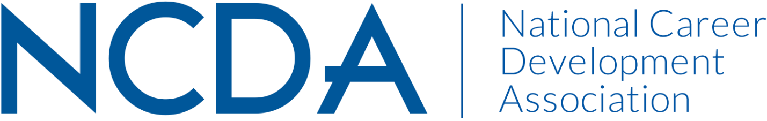

ETHICS COMMITTEE ANNUAL REPORT
August 28, 2024

Co-Chairs:
Conquaya James, MS & EdS  ConquayaJames@hotmail.com  478.241.0466 | David Reile, PhD  David@reile.com

Committee Members

Amanda Chenkin
Amy Policastro- Schroeder
Angie Smith
Azra Siwiec
Becca McCarthy
Billie Streufert
Chris LaFever
Dan Greenwood
Diane Farrell
Duke Wallin
Gillian Johnston
Jaana Kettunen
James Westhoff
Keith Okrosy
Keley Smith-Keler
Lisa Sweet
Manpreet Kaur
Marie Nicks
Mary Guirovich
Michi Mizuno
Ron Cathey
Sarah Patterson- Mills
Sharon Anderson
Shundrika Morris
Stacy VanHorn
Tanisha Stokes
VL Muanpuii

Activities to Date

- Responded to three ethical inquiries from NCDA members (GOALS: Cultivating Community & Advocacy)
- Submitted “Ethics in a Nutshell” articles for the Career Developments magazine (GOALS: Cultivating Community, Career Empowerment, & Advocacy)
- The 2024 NCDA Code of Ethics with Artificial Intelligence (AI) additions was approved and launched during the 2024 NCDA Global Career Development Conference (GOALS: Cultivating Community, Career Empowerment, & Advocacy)
- Surveyed current Committee members to understand their interests and skills and where they wish to focus their efforts during the year (GOALS: Cultivating Community, Career Empowerment, & Advocacy)
  - One former member of the Committee rejoined the team during the Global Conference
  - Began the process of recruiting new members to help broaden the team’s lens
- Working with NCDA President, Marty Apodaca, to form an AI Task Force and to determine work parameters (GOALS: Cultivating Community, Career Empowerment, & Advocacy)

Projected Plan through fiscal year end (September 30th)

- Respond to ethical inquiries
- Write “Ethics in a Nutshell” and Focus articles for the Career Developments magazine
- Prepare to deliver the NCDA Webinar on Ethics in late October
- Recruit new members and prepare for the upcoming year.
- Work with Marty Apodaca and additional members of the AI Task Force

Budget Requests: N/A

