***Subject***: Introducing Your New GCC Leadership Team for 2024-25

Dear GCC Members,

We hope this message finds you well as we move into Fall. As of October 1, 2024, we have taken over from Magdalena Mot, our valued colleague and mentor, to lead the Global Connections Committee at NCDA.

***Meet Your Leadership Team 2024-25***:

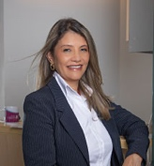

***Chair:*** Marcela Mesa Guerrero, Psychologist, Career Coach, GCDF, FCD-I, CEO Orientarte, Cali, Colombia.

LinkedIn: <https://www.linkedin.com/in/orientartemarcelamesa/>

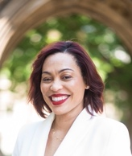***Co-Chair:*** Sonja Robinson, PhD, Educator; Change Management Consultant; Workforce Development Leader; Learning and Training Development Strategist; Nonprofit Leader. Country Director, International Samaritan, Portmore, St. Catherine, Jamaica.

LinkedIn: <https://www.linkedin.com/in/sonjamrobinson/>



***Co-Chair Elect:*** Sepideh Kiazal, Global Talent Leadership Coach DBA, MBA Strategy, MS HRM,

Talent Acquisition Manager & Mentorship Community Coach, Leadership Development

PMI - San Francisco Bay Area Chapter

LinkedIn: <https://www.linkedin.com/in/sepideh-kiazal-l-global-talent-lead-coach-dba-i-mba-strategy-i-ms-hrm-78697151/>

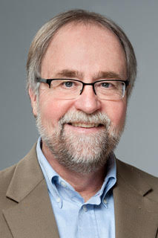

***Board Liaison:*** Jim Peacock, CCSP, Owner of Peak-Careers, Provider of Professional Development for Career Practitioners, Presenter, LinkedIn Trainer, Author

LinkedIn: <https://www.linkedin.com/in/peakcareers/>

At the Global NCDA Conference, we gathered member insights around NCDA’s strategic plan.

The GCC’s mission as stated at NCDA’s webpage is:

*“NCDA’s Global Connections Committee (GCC) strives to foster cross-cultural understanding and provide opportunities for professional growth. GCC members create a welcoming space for practitioners who have expressed interest and concern about international practices in global career development by exchanging and gaining new knowledge from each other. GCC endorses inclusive and equitable career development environments, where people worldwide are empowered to thrive and all voices are heard.”*

NCDA has shared its strategic plan and as a committee we look forward to contribute to make this plan come true: We intend to ***promote engagement*** fostering a strong global career development community through LinkedIn, surveys, virtual career conversations, and member recognition. We will continue to support visibility at events like the NCDA Annual Conference and collaborate with global associations.

Our focus on ***career empowerment*** includes highlighting member presentations and supporting global credentialing. We aim to increase GCC’s presence in NCDA publications and invite research contributions from members.

For ***advocacy***, we will benchmark public policy best practices, contribute to multilingual curriculum development, and advocate for adjusted membership and conference fees based on the Human Development Index.

Our success relies on collective effort. This year, we are excited to introduce bi-monthly virtual ***International Career Conversations***, scheduled across time zones to accommodate members globally. At our first meeting we will agree on time frames, to facilitate the attendance of our diverse members all over the globe.

Please mark these dates in your calendars:

***Thursday, November 7, 2024, 7:00 P.M Central Time***

***GCC International Career Conversation No. 1***

https://us06web.zoom.us/j/85494454164?pwd=h7KAOPqGeuVVh4wGbB6TLZPqqa6RPx.1  
Meeting ID: 854 9445 4164  
Passcode: 201192

The next Meetings are scheduled for the following dates (times to be agreed on our first gathering and following links, also)

* Wednesday, January 22d, 2025
* Thursday, March 27, 2025
* Monday, May 19 th, 2025
* June 18-20, 2025 (date to be scheduled), in Person in Atlanta

We look forward to collaborating with you all and making this a remarkable year for our ***Global Connections Committee*** together.

Sincerely yours,

***GCC Leadership Team 2025***

Marcela Mesa

Sonja Robinson

Sepideh Kiazal