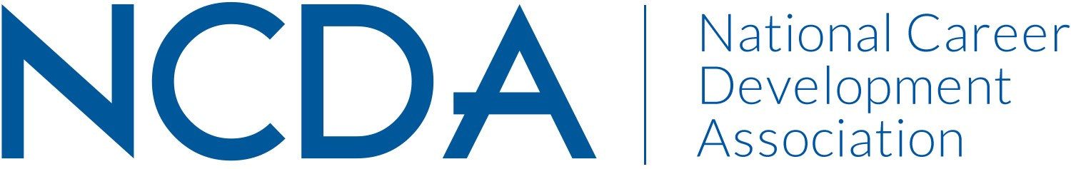

NCDA RESEARCH COMMITTEE REPORT

March 17, 2026

Chair
Deb Osborn
1114 W. Call Street
The Florida State University
Tallahassee, FL 32306-4053
dosborn@fsu.edu

Co-Chair:
Jon Borland
East Tennessee State University
PO Box 70701
Johnson City, TN 37614-1710
borland@etsu.edu

Co-Chair:
Brian Calhoun
Associate Professor of the Practice, Department of Education
Tribble Hall - Room A308B
Wake Forest University
P.O. Box 7406
Winston-Salem, NC 27109
calhoubm@wfu.edu

List Committee Members

Jonathan Adams (lapsed 2024)
Sungsik Ahn
Shadin Atiyeh
Elif Balin
Abby Bjornsen-Ramig
Jon Richard Borland
William Briddick
Nathaniel Brown
Emily Bullock
Stephanie Burrows
Brian Calhoun
Darrin L Carr
Chris S DaSambiagio-Moore
Abiola Dipeolu
Melanie Evangelista
Lia D – Falco
Seth C. W. Hayden
Latoya Haynes-Thoby
Janet Hicks
Youn Jung Ho
Kimberly Howard
Chris Lafever
Jason Li
Qiong Li
Yangyang Liu
Ayla Ludwig
Julia Makela
Spencer Niles
Kelechi Nnaji
Sarah Patterson-Mills
Sabrina Quiroga
Patrick J. Rottinghaus
Donna E Schultheiss
Rana Sedeeq
Patricia Smith
V. Scott Solberg
Jacob Stamm
Tennille Sullivan
Mitali Temurnikar
Margi Williams

Committee/Council Activities to Date
We continued to work on our clarifying our budgetary requests to the Board and had a meeting to confirm these. We narrowed the activities under consideration to include 1) the updating of the effectiveness of career interventions white paper with collaboration from ACES and SVP; and 2) the development of career briefs on selected topics. We ultimately decided to focus solely on the first activity (CAREER EMPOWERMENT; ADVOCACY) until we could determine how to maintain sustainability of the second. Since that time, the chair has spoken with the ACES president twice who has confirmed interest. SVP has been less responsive, but this may be due to a changing over in leadership.

Utilizing the changes made to the mid and end of year reports, we followed up with those stating their committee was engaged in research. No research was planned that would be utilizing NCDA membership.

In addition to these activities, we reviewed, voted on, and ultimately approved a request to use the NCDA membership for a dissertation survey.

Projected Plan/Work Planned to be Completed through September 30.
By the end of the fiscal year, we anticipate having completed our tasks of providing recommendations to the awards committee for the two NCDA awards, CDQ article of the year and the graduate student research award. (CULTIVATING COMMUNITY) We will continue to review research proposals that plan to utilize NCDA membership. We will aim to complete the white paper on career interventions (CAREER EMPOWERMENT; ADVOCACY).

